**CALM CONNECT: EMPOWERING YOUR MENTAL WELLNESS JOURNEY USING WEB TECHNOLOGIES AND OPEN AI**

## INNOVATIVE PRODUCT DEVELOPMENT REPORT

***Submitted by***

|  |  |  |
| --- | --- | --- |
| **B. Jyothika** | **A. Neha** | **E. Vaishnavi** |
| **22RH1A6625** | **22RH1A6606** | **22RH1A6650** |

***Under the Esteemed Guidance of***

**Dr. G. Kalpana**

**Professor**

***in partial fulfillment of the Academic Requirements for the Degree of***

**BACHELOR OF TECHNOLOGY**

CSE-AI & ML



**MALLA REDDY ENGINEERING COLLEGE FOR WOMEN**

**Autonomous Institution-UGC, Govt. of India** **Accredited by NAAC with ‘A+’ Grade,**

**Affiliated to JNTUH, Approved by AICTE, ISO 9001:2015 Certified Institution Maisammaguda (V), Dhullapally (Post), (Via) Kompally, Medchal Malkajgiri Dist. T.S-500100**

## APRIL- 2025

**MALLA REDDY ENGINEERING COLLEGE FOR WOMEN**

**Autonomous Institution, UGC, Govt. of India Accredited by NAAC with A+ Grade**

**Affiliated to JNTUH, Approved by AICTE, ISO 9001:2015 Certified Institute Maisammaguda (V), Dhullapally (Post), (Via) Kompally, Medchal Malkajgiri Dist. T.S-500100**

**DEPARTMENT OF CSE - AI &ML**

## CERTIFICATE

This is to certify that the Innovative Product Development work CALM CONNECT: EMPOWERING YOUR MENTAL WELLNESS JOURNEY USING WEB TECHNOLOGIES AND OPEN AI is carried out by **B. Jyothika(22RH1A6625), A. Neha(22RH1A6606), E. Vaishnavi(22RH1A6650)** in partial fulfillment for the award of degree of **BACHELOR OF TECHNOLOGY** in CSE - AI & ML, Jawaharlal Nehru Technological University, Hyderabad during the academic year 2023-2024.

**Supervisor’s Signature Head of the Department Dr. G. Kalpana Dr. G. Kalpana**

**Professor Professor**

**External Examiner**

**Autonomous Institution, UGC, Govt. of India Accredited by NAAC with A+ Grade**

**Affiliated to JNTUH, Approved by AICTE, ISO 9001:2015 Certified Institute Maisammaguda (V), Dhullapally (Post), (Via) Kompally, Medchal Malkajgiri Dist. T.S-500100**

# Department of CSE –AI & ML DECLARATION

We hereby declare that the Innovative Product Development entitled **CALM CONNECT: EMPOWERING YOUR MENTAL WELLNESS JOURNEY USING WEB TECHNOLOGIES AND OPEN AI** submitted to Malla Reddy Engineering College For Women affiliated to Jawaharlal Nehru Technological University, Hyderabad (JNTUH) for the award of the Degree of Bachelor of Technology in CSE-AI & ML is a result of original research work done by us. It is further declared that the Innovative Product Development report or any part thereof has not been previously submitted to any University or Institute for the award of Degree.

**B. Jyothika(22RH1A6625)**

**A. Neha(22RH1A6606)**

**E. Vaishnavi(22RH1A6650)**

# ACKNOWLEDGEMENT

We feel ourselves honored and privileged to place our warm salutation to our college **Malla Reddy Engineering College for Women** and **Department of CSE-AI&ML** which gave us the opportunity to have expertise in engineering and profound technical knowledge.

We would like to deeply thank our Honorable MLA of Telangana State **Sri**.**Ch. Malla Reddy Garu,** founder chairman MRGI, the largest cluster of institutions in the state of Telangana for providing us with all the resources in the college to make our project success.

We wish to convey gratitude to our **Principal Dr. Y. Madhavee Latha,** for providing us with the environment and mean to enrich our skills and motivating us in our endeavor and helping us to realize our full potential.

We would like to thank **Prof. A. Radha Rani**, Director of Computer Science and Engineering & Information Technology for encouraging us to take up a project on this subject and motivating us towards the Project Work.

We express our sincere gratitude to **Dr. G. Kalpana , Head of the Department** of CSE–AI&ML for inspiring us to take up a project on this subject and successfully guiding us towards its completion.

We would like to thank our guide **Dr. G. Kalpana, professor** of CSE-AI&ML and all the Faculty members for their valuable guidance and encouragement towards the completion of our project work.

**With Regards and Gratitude**

**B. Jyothika (22RH1A6625)**

**A. Neha(22RH1A6606)**

1. **Vaishnavi (22RH1A6650)**

**ABSTRACT**

In an era where mental health is increasingly recognized as vital to overall well-being, *Calm Connect* emerges as a powerful digital ally in promoting emotional resilience and personal growth. This innovative platform harnesses the power of modern web technologies and OpenAI's advanced language models to deliver personalized, accessible, and empathetic mental wellness support. Through an intuitive user interface and seamless integration of intelligent natural language processing, Calm Connect offers features such as mood tracking, AI-guided journaling, mindfulness prompts, and conversational support tailored to individual emotional needs. Designed to bridge the gap between traditional therapy and everyday mental wellness, this solution emphasizes privacy, accessibility, and user empowerment. By blending technology with empathy, Calm Connect redefines self-care in the digital age and fosters a safe space for reflection, growth, and emotional connection.

**INDEX**

|  |  |
| --- | --- |
| **TITLE** | **i** |
| **CERTIFICATE** | **ii** |
| **DECLARATION** | **iii** |
| **ACKNOWLEDGMENT ABSTRACT** | **iv v** |
| **1. INTRODUCTION** | **1** |
| 1.1 Project Definition | 1 |
| 1.2 Project Overview | 1 |
| 1.3 Software Requirements | 1 |
| 1.4 Hardware Requirements | 1 |
| **2. LITERATURE SURVEY** | **2** |
| 2.1 Existing System | 2 |
| 2.2 Disadvantages | 2 |
| 2.3 Proposed System | 2 |
| 2.4 Advantages | 2 |
| **3. METHODOLOGY** | **3** |
| **4 SYSTEM ARCHITECTURE** | **5** |
| **5. IMPLEMENTATION** | **6** |
| **6. RESULTS** | **15** |
| **7. CONCLUSION & FUTURE SCOPE** | **20** |
| **REFERENCES** |  |

# CHAPTER 1 INTRODUCTION

## PROJECT DEFINITION

## Calm Connect is a web-based platform developed to empower users on their mental wellness journey by providing accessible, personalized emotional support. Utilizing modern web technologies and OpenAI’s advanced natural language processing, the platform offers features such as mood tracking, AI-guided journaling, mindfulness prompts, and an empathetic conversational assistant. It is designed to create a safe and private digital space where users can reflect, grow, and manage stress effectively.

## PROJECT OVERVIEW

## Calm Connect is a mental wellness web application that offers personalized support through AI-driven tools. It combines mood tracking, journaling, and mindfulness prompts with OpenAI’s conversational intelligence. The platform is designed for accessibility, privacy, and emotional engagement. Calm Connect empowers users to manage their mental health anytime, anywhere with ease and empathy.

## SOFTWARE REQUIREMENTS :

* Operating System - Windows 10
* Programming Language - Python 3.7.0

## HARDWARE REQUIREMENTS :

# Processor - Intei I3(min)

* Speed - 1.1 Ghz
* RAM - 256 MB(min)
* Hard Disk - 20 GB
* Key Board - Standard Windows Keyboard
* Mouse - Two or Three Button Mouse
* Monitor - SVGA

# CHAPTER 2

## LITERATURE SURVEY

### Existing System:

* A questionnaire that helps detect possible mental health conditions.
* Resources and support materials related to mental well-being.

### Proposed System:

The CALM CONNECT is a web-based platform designed to help users assess their mental well-being through a structured survey. Based on responses, it analyzes conditions such as depression, anxiety, and OCD, providing personalized insights and self-care recommendations. The system ensures user privacy and confidentiality while offering accessible mental health support.

**Disadvantages :**

* The application lacks responsiveness.
* It relies on human work.
* The user undergoes into a long procedure.

**Advantages :**

* Easy & Accessible Simple, user-friendly interface.
* Personalized Insights Provides tailored mental health assessments.
* Self-Care Support - Offers coping strategies and wellness tips.
* Early Detection Helps users identify potential issues early.
* Secure & Confidential-Ensures data privacy and anonymity.
* Cost-Effective Free or low-cost alternative to professional consultations.

# CHAPTER 3

## METHODOLOGY

## 1. User Interaction and Survey Intake

## The process begins with user interaction through a web-based interface, where individuals are invited to take a structured self-assessment survey. This questionnaire is carefully designed to screen for symptoms of common mental health conditions such as depression, anxiety, and obsessive-compulsive disorder (OCD). The questions aim to understand the user’s emotional state, behavior patterns, and thought processes.

## 2. Data Processing and Analysis

## Once the survey is submitted, the user responses are processed using backend logic integrated with OpenAI’s natural language processing capabilities. The system interprets the data to identify mental health indicators and generates a personalized analysis. This ensures the assessment is not only data-driven but also sensitive to the nuanced emotional context of the user.

## 3. Result Generation and Recommendations

## Based on the analysis, the platform provides users with a customized result summary. This includes an overview of potential mental health conditions detected and personalized suggestions for self-care. These may range from breathing techniques and journaling prompts to recommendations for seeking professional support if needed. The aim is to empower users to take proactive steps toward improving their mental health.

**4. Deployment and Continuous Improvement**

The platform is developed using modern web technologies, ensuring ease of access across devices. Post-deployment, the system undergoes continuous updates based on user feedback, performance analysis, and advancements in AI. New features such as improved diagnostics and expanded chatbot functionality are incorporated over time.

**5. Data Storage and Privacy Protection**

Security and privacy are core principles of Calm Connect. All user data is encrypted and securely stored, with strict policies to ensure confidentiality and anonymity. This helps build user trust and encourages more honest and open participation, crucial in the sensitive area of mental health.

# CHAPTER 4

## SYSTEM ARCHITECTURE

┌────────────────────────┐

│ CLIENT SIDE (Frontend) │

│ React.js SPA (UI Components): │

│ - Landing Page │

│ - Login / Authentication │

│ - Mental Health Survey │

│ - Results Dashboard │

│ - Tips & Resources │

└───────────────────────┘

│

▼

┌────────────────────────────┐

│ SERVER SIDE (Node.js + Express) │

│ - /api/auth → Login, JWT │

│ - /api/questions → Fetch survey │

│ - /api/submit → Submit responses │

│ - /api/results → Analyze & return feedback │

└──────────────────────────┘

│

▼

┌──────────────────────────┐

│ AI Engine – OpenAI API Integration │

│ - Analyze answers │

│ - Generate mental health tips │

└───────────────────────┘

│

▼

┌─────────────────────────┐

│ Database (MongoDB/MySQL) │

│ - Store users, responses, resources │

└──────────────────────┘

# 

# CHAPTER 5

# 

# IMPLEMENTATION

**5.1 Html:**

HTML is the standard markup language used to create the structure of web pages. It defines the layout and elements such as headings, paragraphs, links, and forms. By organizing content into meaningful sections, HTML serves as the backbone of any website. It provides the basic framework that other technologies enhance.

**5.2 Css:**

CSS is used to style and visually enhance HTML elements on a web page. It controls the layout, colors, fonts, spacing, and responsiveness of the site. With CSS, developers can create visually appealing interfaces and ensure consistent design across different devices. It helps transform raw HTML into an engaging user experience.

**5.3 Javascript:**

JavaScript is a programming language that adds interactivity and dynamic behavior to web pages. It allows users to engage with elements such as buttons, forms, and animations in real time. JavaScript can manipulate HTML and CSS, enabling features like content updates without reloading the page. It plays a key role in building responsive and interactive web applications.

**5.4 React Js:**

React.js is a popular JavaScript library used for building dynamic and interactive user interfaces. Developed by Facebook, it allows developers to create reusable components that update efficiently with changes in data. React enhances performance through its virtual DOM and supports the creation of single-page applications. It’s widely used for developing responsive, user-friendly web apps.

**5.5 Node Js:**

Node.js is a runtime environment that allows JavaScript to be used for backend development. It enables fast and scalable server-side applications by running code outside the browser. With its event-driven, non-blocking architecture, Node.js is ideal for handling real-time data and API requests. It plays a key role in building full-stack JavaScript applications.

**5.6 Open AI:**

OpenAI provides advanced artificial intelligence models, such as GPT, that can understand and generate human-like text. It is used to power features like chatbots, smart recommendations, and natural language understanding. By integrating OpenAI APIs, developers can build intelligent applications that interact with users in meaningful ways. In Calm Connect, OpenAI enhances the user experience through empathetic, AI-driven conversations and insights.

## SOURCE CODE

# .carousel{

# /* width:-12%; */

# }

# .image_size{

# height: 400px;

# width: 300px;

# }

# h1 {

# margin: 1rem auto 4rem;

# }

# .product--image {

# width: 70%;

# height: 20em;

# object-fit:contain;

# }

# .card {

# display: flex;

# flex-direction: row;

# box-shadow: 0 4px 8px 0 #000;

# max-width:80rem;

# max-height: 2000rem;

# /* margin: auto 1rem; */

# margin-bottom: 2rem;

# margin-top: 0rem;

# text-align: center;

# font-family: arial;

# background-color: #fff;

# /* filter: blur(4px); */

# }

# .info{

# /* border: 10px solid black; */

# width: 450px;

# margin-left: 12rem;

# padding-top: 30px;

# color: rgb(0, 0, 0);

# }

# export const QuizData = [

# // depression

# {

# question: "In the past month, how often have you felt overwhelmingly sad?",

# options:["Not at all","At times","More than half the days","Nearly every day"],

# answer: [2,3],

# illness: "Depression"

# },

# {

# question: "Have you had any thoughts of suicide or have you felt hopeless about the future?",

# options:["Never","Strongly disagree","Strongly agree"],

# answer: [1,2],

# illness: "Depression"

# },

# {

# question: "How is your sleep?",

# options:["Sleeping as usual","Slight difficulty", "A lot of difficulties"],

# answer: [2],

# illness: "Depression"

# },

# {

# question: "Do you prefer to stay at home rather than going out and doing new things?",

# options:["Yes","No"],

# answer:[0],

# illness: "Depression"

# },

# {

# question: "Have you been feeling tired or having little energy?",

# options:["Not at all","Almost every day","I feel hopeless and I don't feel like working at all" ],

# answer:[1,2],

# illness: "Depression"

# },

# //ptsd

# {

# question: "Have you experienced a traumatic event during your life that you think is affecting you?",

# options:["Yes, I did recently","Yes I have childhood trauma", "No I don't think so"],

# answer:[0,1],

# illness: "PTSD"

# },

# {

# question: "Do you regularly relive or re-experience the event?",

# options:["Yes, I get Flashbacks/Nightmares","At times", "No"],

# answer:[0],

# illness: "PTSD"

# },

# //

# {

# question: "Do you avoid certain people, situations, or places?",

# options:["Yes, I do upto an uncomfortable point","I do at times","No"],

# answer:[0],

# illness: "PTSD"

# },

# //

# {

# question: "Have you withdrawn from friends, family, or other loved ones?",

# options:["Yes","No"],

# answer:[0],

# illness: "PTSD"

# },

# {

# question: "I am aware I have a lot of feelings about what happened but I haven’t dealt with them",

# options: ["Not at all","A little","Sometimes","Quite a lot"],

# answer:[3],

# illness:"PTSD"

# },

# // anxiety

# {

# question: "How often have you been bothered by feeling nervous, anxious or on edge over the last one month?",

# options:["Not at all","Several days", "Almost everyday"],

# answer:[1,2],

# illness: "Anxiety"

# },

# //

# {

# question: "How often have you been bothered by not being able to stop or control worrying over the last month?",

# options:["Almost everytime","Mostly", "Not much"],

# answer:[0,1],

# illness: "Anxiety"

# },

# //

# {

# question: "How often have you been bothered by having trouble relaxing ?",

# options:["Most of the times","I have been relaxed", "Quite some times"],

# answer:[0,2],

# illness: "Anxiety"

# },

# //

# {

# question: "How often have you been bothered by becoming easily annoyed or irritable ?",

# options:["I got irritated a lot","Not at all", "I did get irritated at times"],

# answer:[0],

# illness: "Anxiety"

# },

# {

# question: "How often have you been bothered by becoming easily annoyed or irritable ?",

# options:["I got irritated a lot","Not at all", "I did get irritated at times"],

# answer:[0],

# illness: "Anxiety"

# },

# // adhd

# {

# question: "My mind feels very cluttered and it is hard for me to concentrate on one thing at a time",

# options:["Almost everytime","I don't have troubles", "At times"],

# answer:[0],

# illness: "ADHD"

# },

# //

# {

# question: "How often do you have difficulty keeping your attention when you are doing boring or repetitive work?",

# options:["I make a lot of mistakes during boring work","Boring work seems to demotivate me","I don't make mistakes"],

# answer:[0],

# illness: "ADHD"

# },

# {

# question: "Do you consider yourself impulsive?",

# options:["I am very impulsive","I am not impulsive"],

# answer:[0],

# illness: "ADHD"

# },

# {

# question: "If a task or project requires a lot of thought I will often delay in getting it started",

# options: ["Never","Rarely","Sometimes","Very often"],

# answer:[3],

# illness:"ADHD"

# },

# 

# 

# CHAPTER 6

## OUTPUT RESULTS

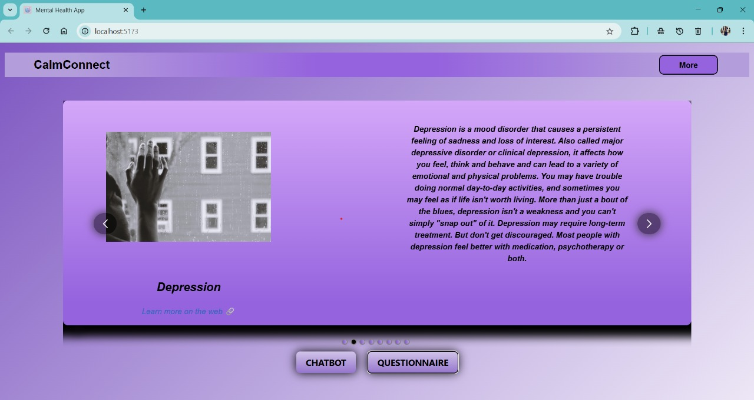

**Fig.7.1 Dashboard**

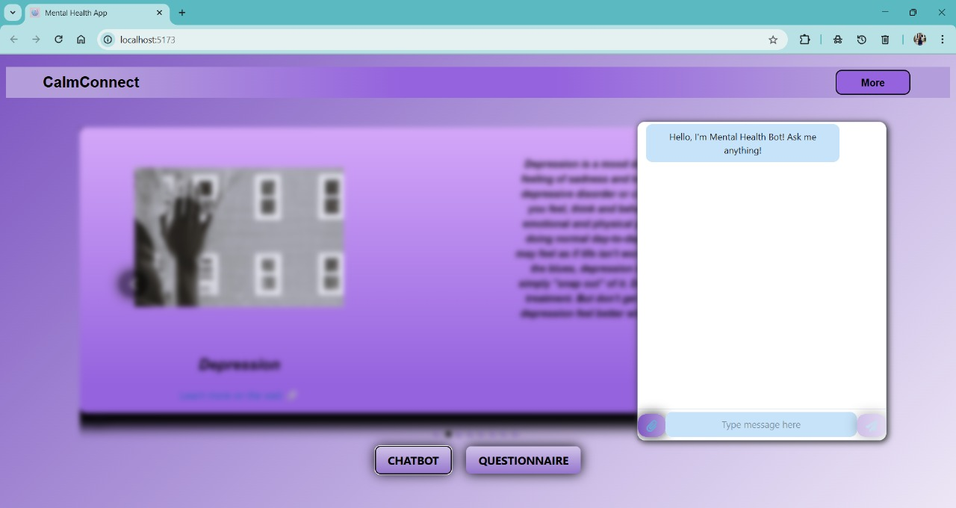

**Fig.7.2 Chatbot**

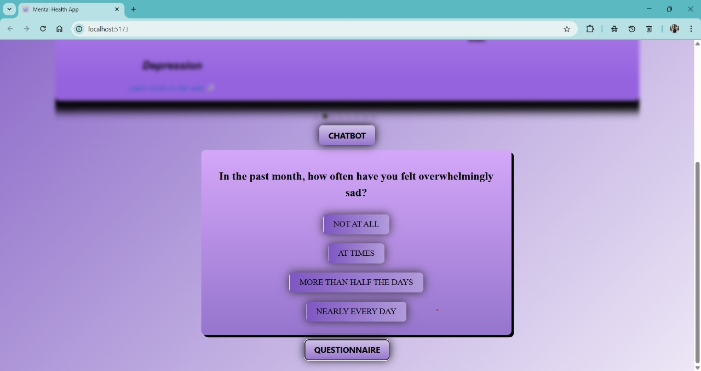

**Fig. 7.3 Questionnaire**

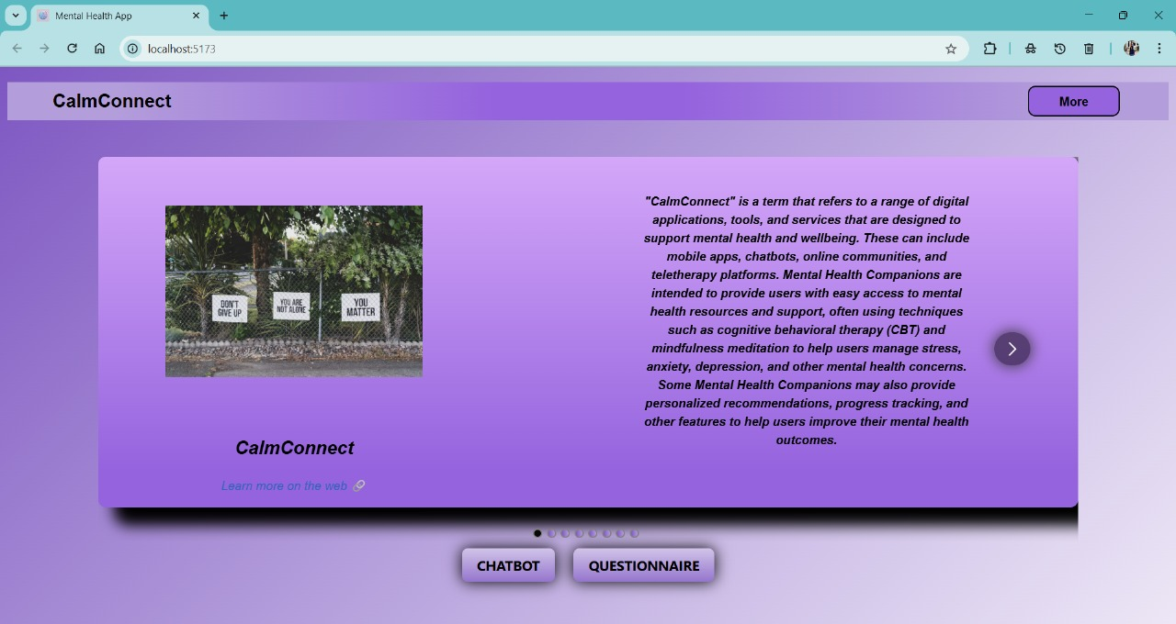

**Fig.7.4 Description of metal health**

# CHAPTER 7

## CONCLUSION AND FUTURE SCOPE

Calm Connect is an innovative mental wellness platform that effectively combines web technologies like HTML, CSS, JavaScript, React.js, and Node.js with OpenAI’s powerful language model to deliver personalized mental health support. The application offers a smooth user experience, secure data handling, and AI-driven insights through a chatbot and tailored assessments. It empowers users to identify early signs of mental health issues and take timely action through accessible, stigma-free tools.

In the future, Calm Connect aims to expand its capabilities by integrating wearable device data for real-time monitoring, enhancing chatbot emotional intelligence, and supporting multiple languages. The platform may also introduce features like gamified self-care activities, therapist directories, and community forums. With continuous updates and smart AI integration, Calm Connect holds great potential to become a holistic and intelligent mental wellness companion.

## 

## REFERENCES

1. World Health Organization (WHO) – Mental health resources and global statistics. <https://www.who.int/health-topics/mental-health>
2. American Psychological Association (APA) – Guidelines on mental health assessments and therapy. <https://www.apa.org/>
3. National Institute of Mental Health (NIMH) – Research and insights on depression, anxiety, and OCD. <https://www.nimh.nih.gov/>
4. Mayo Clinic – Expert articles on symptoms, diagnosis, and treatment of mental health conditions. <https://www.mayoclinic.org/diseases-conditions>
5. Harvard Medical School – Health Blog – Latest research and studies on mental well-being. <https://www.health.harvard.edu/blog>